Dalry Health Centre
Winter Newsletter

Meet the Team
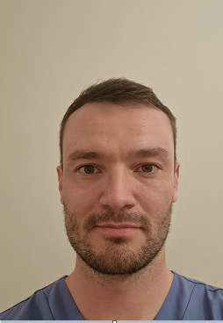
We are delighted to welcome Dr Pete Shepherd to the Practice. Some of you will already know Dr Shepherd as he has been working as a locum with us for the past year, but he is now taking up a Partner post as from Monday, 6th November. He will be in the Practice on a Monday and a Tuesday. We are delighted to have him with us permanently.
Dr Shepherd graduated from the University of Aberdeen Medical School in 2014 and worked in Ayrshire and Glasgow for several years in A&E. He moved to Australia for a year to work in A&E before returning to commence his GP training in Lanarkshire, where he qualified in 2022.
Dr Shepherd’s interests are music, rugby, football and travel.
Winter Vaccinations
Flu and COVID are being co-ordinated by NHS Ayrshire and Arran and all patients eligible will receive an appointment to attend a vaccination centre.
The Practice will invite all patients due a shingles or pneumococcal vaccination to attend a clinic at the Practice.
Childhood Immunisations
Unfortunately childhood immunisation appointments are not being managed by the Surgery. The Child Health Department at Ayrshire Central Hospital will appoint all children due their routine immunisations. If you need to reschedule an appointment please call 01294 317628.
Prescriptions
Please order your medications on time, allowing time for your preferred pharmacy to have it ready
Prescriptions can be ordered by calling 01294 832523 between the hours of 10am and 12 noon and 2pm and 4pm. You can also order via our prescription mailbox DalryHealthCentre_Prescriptions@aapct.scot.nhs.uk, or by posting your request through our letterbox.
Please list the names of the items you require and only order what you need.
If you have previously consented for a preferred pharmacy, your prescription will automatically be sent to that Pharmacy.
If for any reason there is an issue with your requested item that needs to be discussed, we will contact you.
If you are advised to arrange a medication review, pill check or HRT check, please do so in plenty of time. Appointments can be booked in advance.
Test Results
Blood test and x-rays etc. take varying times to be processed and reported. We understand you are anxious to know your results however we do ask that you give us time to process them.
Whilst we do not contact you for normal results, please be assured that we will contact you if any follow up or treatment is required. If you have not heard from us after a week, please give us a call. Please call between the hours of 2pm and 4pm.
Be Part of Something that can make a difference
Our PPG is always happy to receive new members. We meet four times a year and chat about the current activities and topics of interest. The meetings are interactive and informative, giving patients greater insight into the processes and workings of the Practice and beyond and the Practice opportunities for development and improvement. If you would like to join our Group please let a member of the Team know.
Dates to Remember
The surgery will close at 1 pm on Tuesday, 21st November 2023 for staff training. If you have an urgent medical matter that afternoon please call 01563 826930
The Practice will close for Christmas and New Year on the following dates:
Christmas Day Monday 25th December
Boxing Day Tuesday 26th December

New Year’s Day Monday 1st January 2024
Public Holiday Tuesday 2nd January 2024

